Linux Servers
Classroom Assignment 6 – Hostnames and DNS
Document your commands or take screenshots. Answer questions in english or finnish.

Hostnames
Configure all your VMs with the correct hostnames given in the topology picture. Add them to the hosts files also so you can use hostnames when pinging. Test with ping.
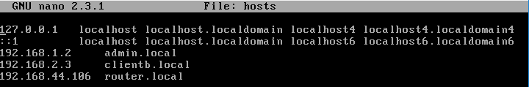
Muokkasin sitten kaikkien koneiden etc/hostnamen ja laitoin nimet router.local routerille, admin.local adminille ja clientb.local clientb:lle. Testasin pingin toimivuutta hostnamella admin koneelta routerille ja clientb:lle
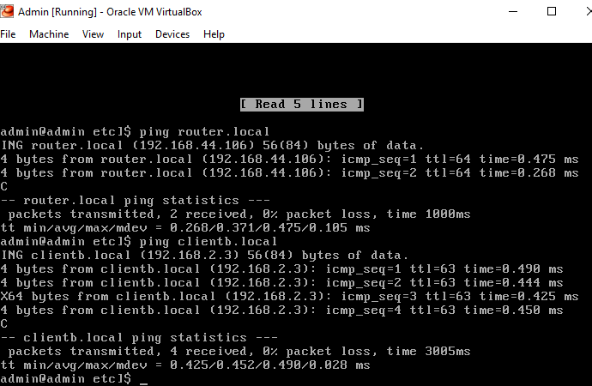
Ja clientb:ltä admin koneelle
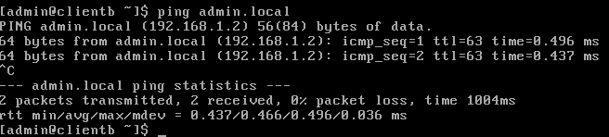
Pingit toimivat

DNS servers
Find out what DNS servers the Router.local VM gets automatically from the LabraNet DHCP server. Configure the other VMs to use these DNS-servers also. You should now have a fully working Internet access on all of the VMs. Test with ping, traceroute, nslookup and other tools.
Router käyttää nimipalvelimia:
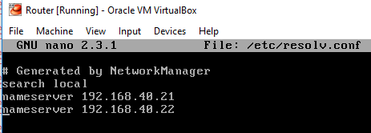
Muokkasin admin ja clientb:n koneisiin nimipalvelimet resolv.conf tiedostoon
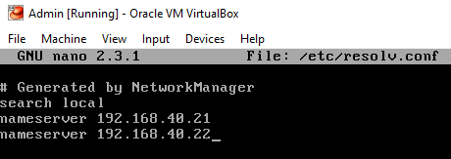
Kokeilin traceroutee iltalehti.fi clientb-koneella
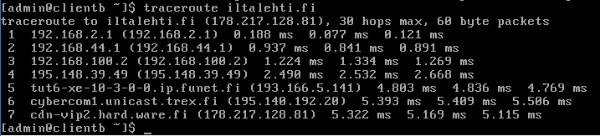

Name lookup
With the dig -tool, find out the next information:
- How many different IP addresses are behind www.iltasanomat.fi?
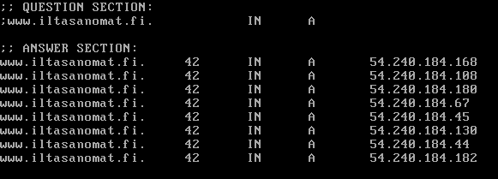
- What are the nameservers for the sonera.fi domain?
Käytin komentoa dig NS sonera.fi
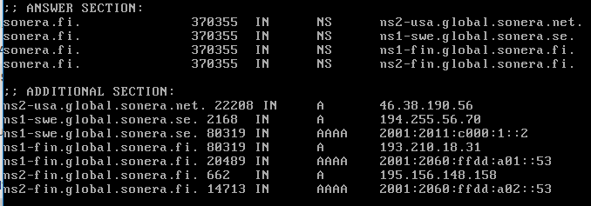
- Does jamk.fi have an IPv6 address? How about google.com?
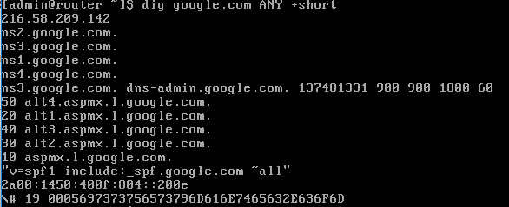
Jamkilla ei ole IPv6 osoitetta, googlella on
- What server is responsible for E-mail to @jamk.fi –addresses? How about @student.jamk.fi?
Käytin komentoa dig jamk.fi MX
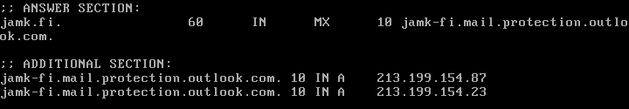
Student:
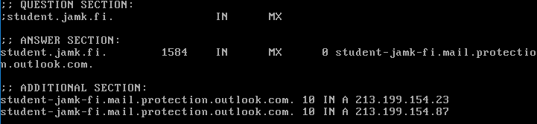
- Do a reverse lookup for IP address 195.148.26.130. What is this server?
Käytin komentoa dig –x
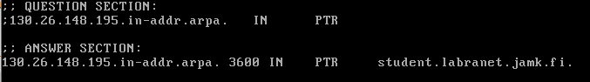
- Do a full trace of the name student.labranet.jamk.fi. How many different nameservers are responsible for the whole query?
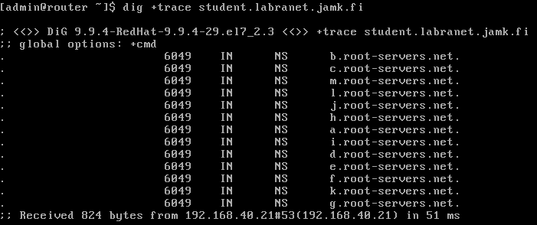
13 nimipalvelinta on queryn takana.

